Name : Saurabh Jadhav

Topic : Creating Load Balancer for web server.

Assignment no. : 11

1. Create two EC2 instances in different AZ.

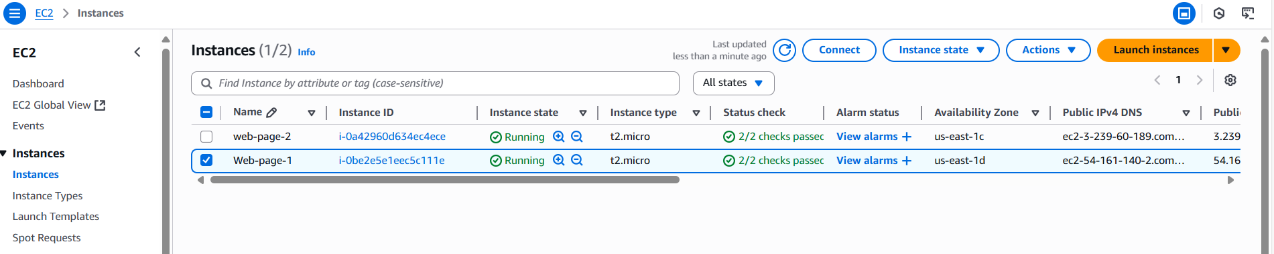

1. Make “web-page-1” server ready as web server.

Yum install httpd -y

Systemctl start httpd

Systemctl enable httpd

Systemctl status httpd

1. Install apache package and start the service

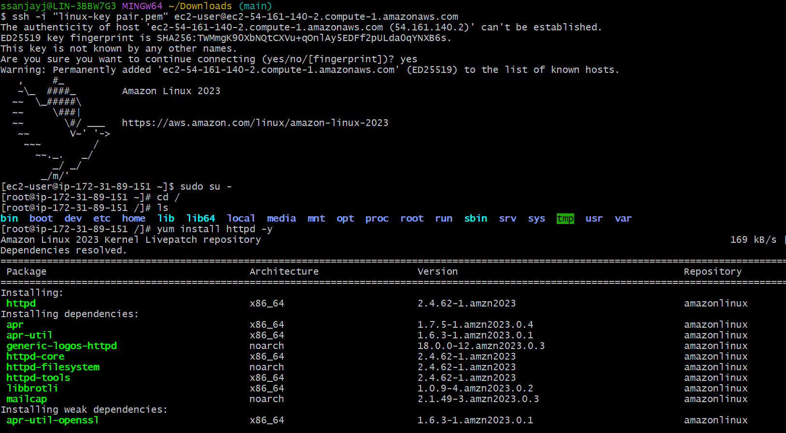

1. Create index.html file in /var/www/html

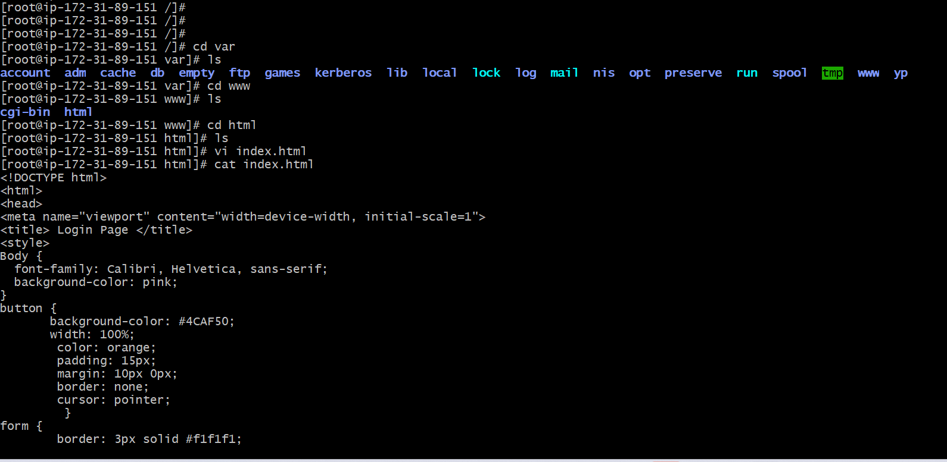

1. Access the web page using public ip of EC2 instance.

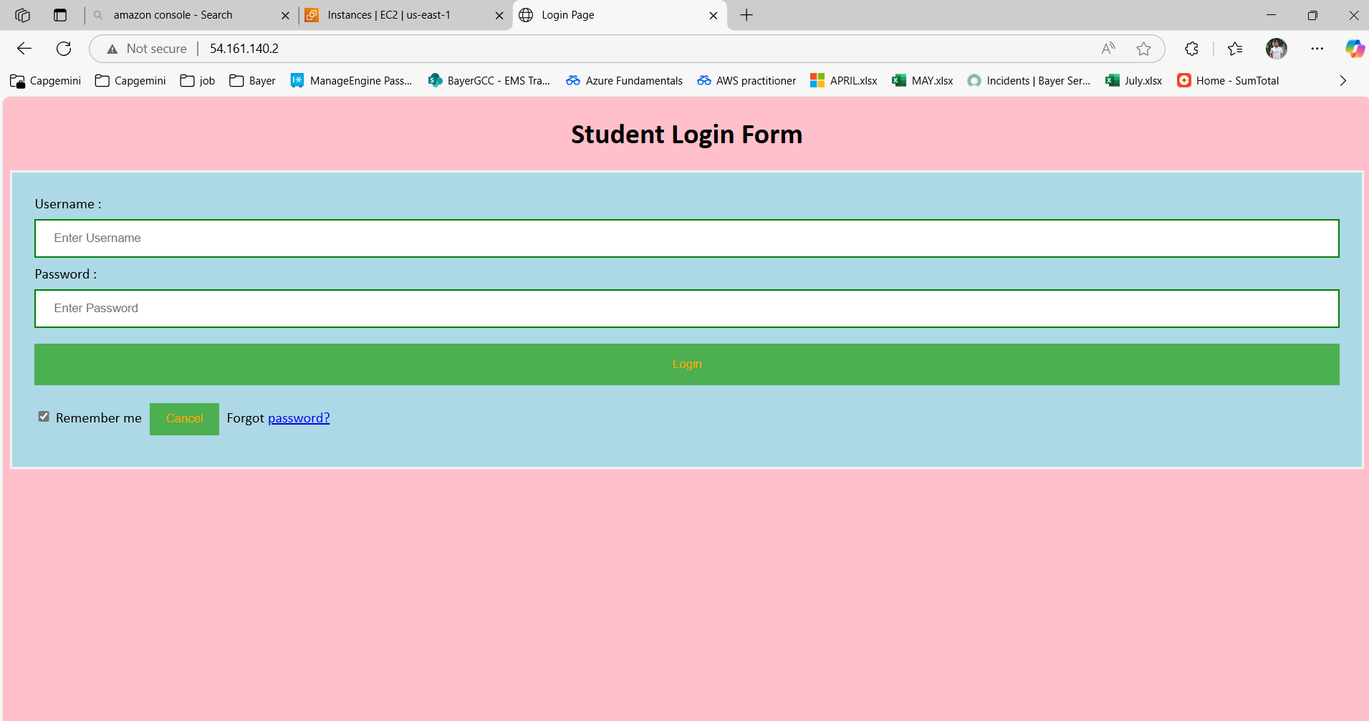

1. Similarly make “web-page-2” ready as web server.
2. Install apache package and start the service.

1. Create index.html and access it using public ip as EC2 instance.

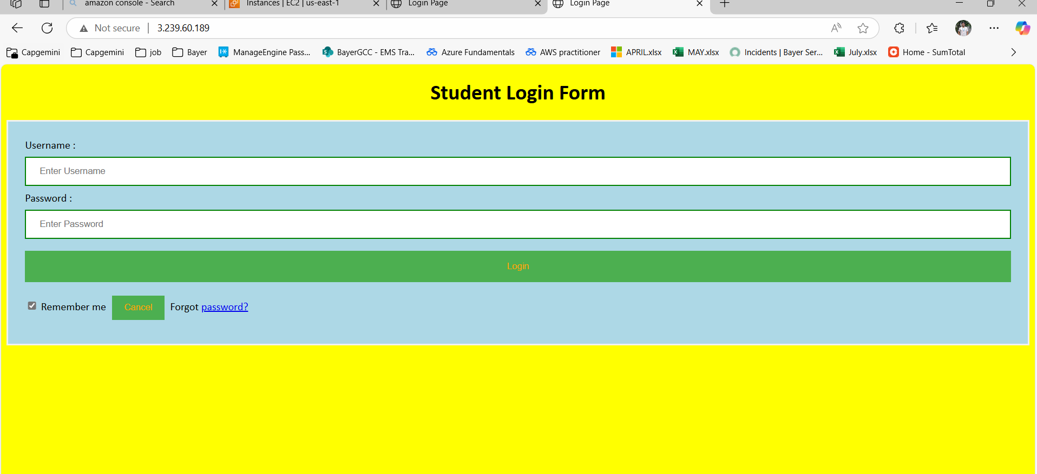

1. Create target group for load balancer.
2. Basic configurations of group type.

1. Target group name as “web-lb” and keep other settings as default.

1. Select the instances for the group and click on create target group

1. Create load balancer.
2. Select the load balancer type – Application load balancer.

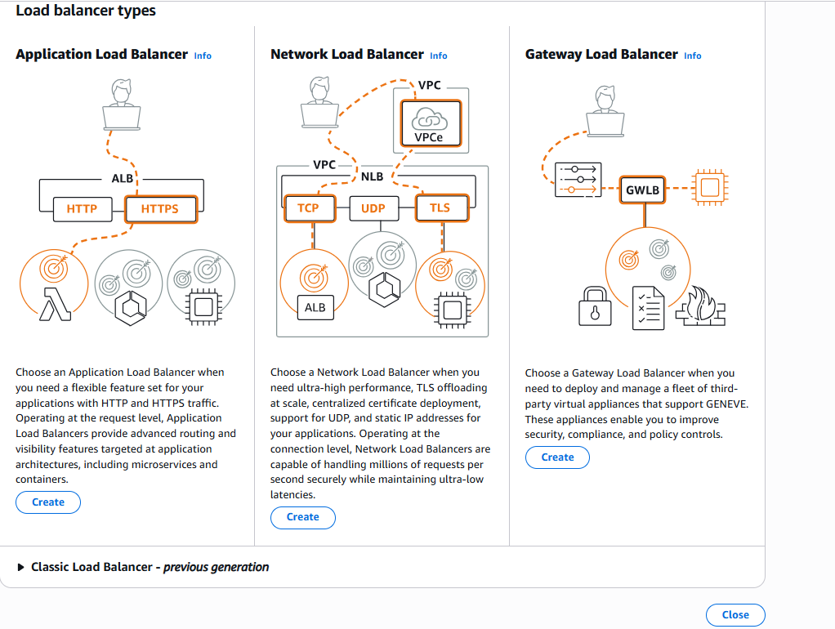

1. Provide load balancer name “web-app-lb”

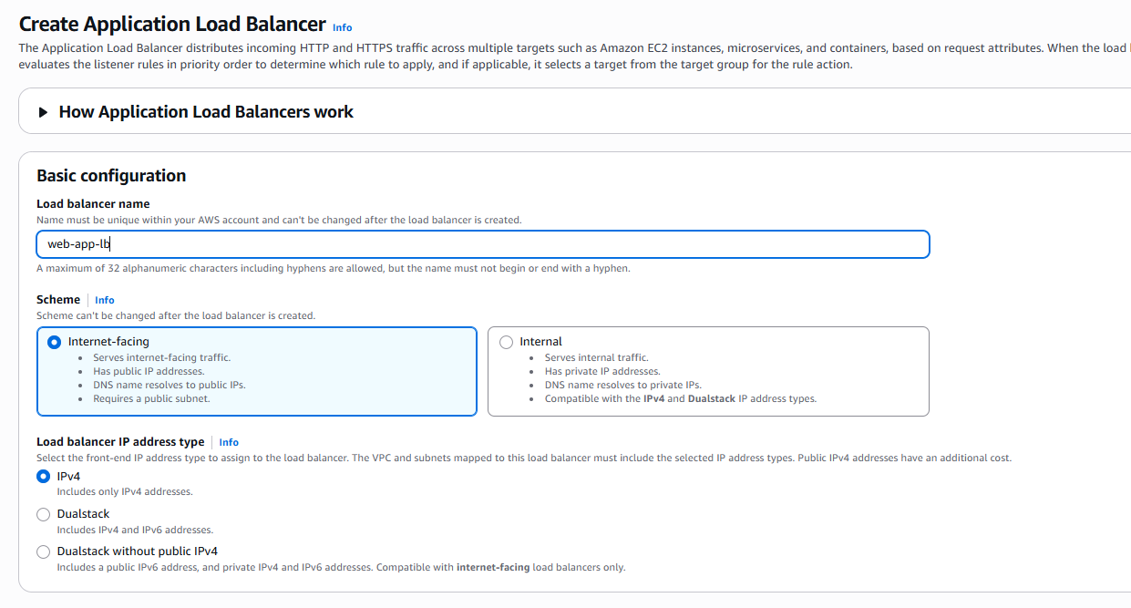

1. Select all the AZ for network mapping.

1. Select the target group “web-lb” as listener.

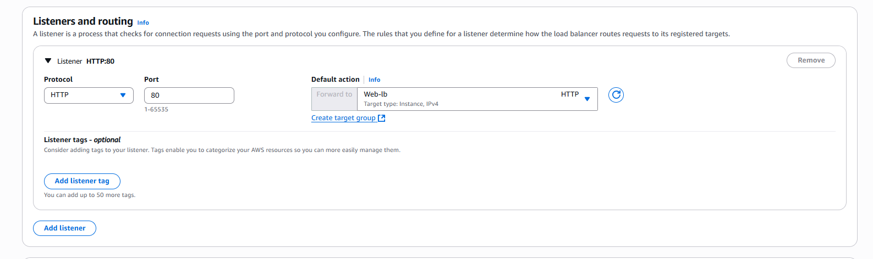

1. Check the summary of load balancer.

1. Copy the dns link and refresh it continuously to check the performance of load balancer.

